Motion | Tp(s) | f(rad/s)
Surge | 115 | 0.055
Sway | 125 | 0.05
Heave | 31.4 | 0.2
Roll/pitch | 32.7 | 0.19
Yaw | 7.5 | 0.838
Wave: 0.44
Cased 1 All blades are feathered V=38.7, Hs=12, Tp=14.2 position1
Cased 2 Blade1&3 feathered, blade2 seized and flat to the wind, V=38.7, Hs=12, Tp=14.2 position1
I Dynamic response
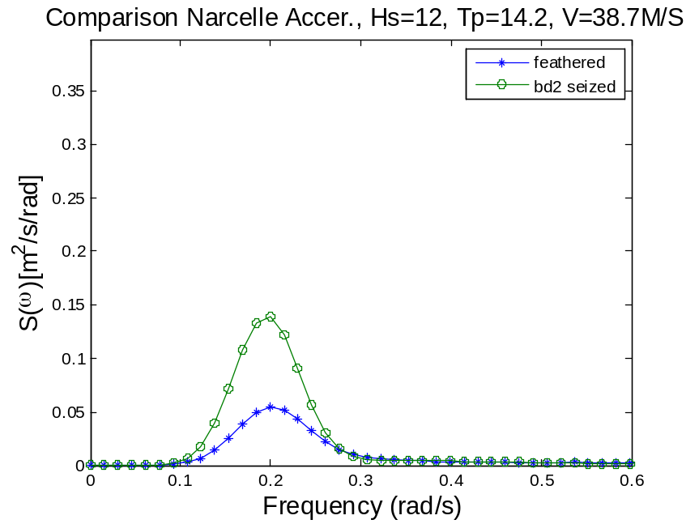
The nacelle accer. Is dominated by pitch resonant response
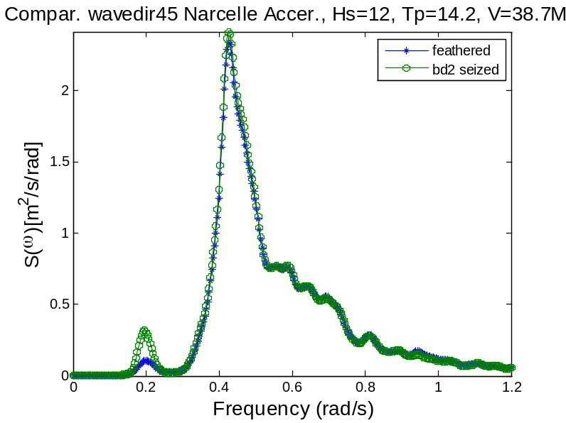

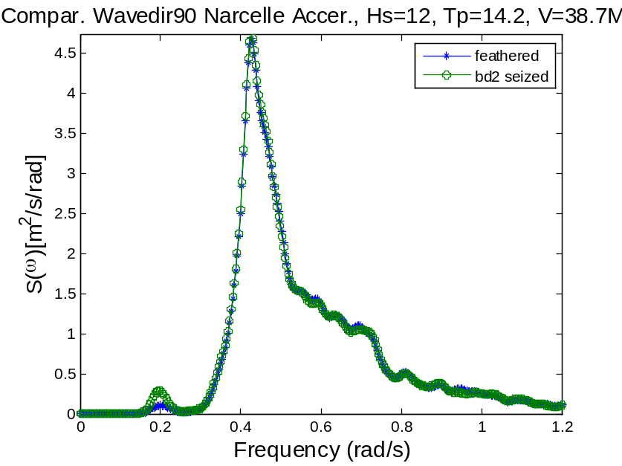
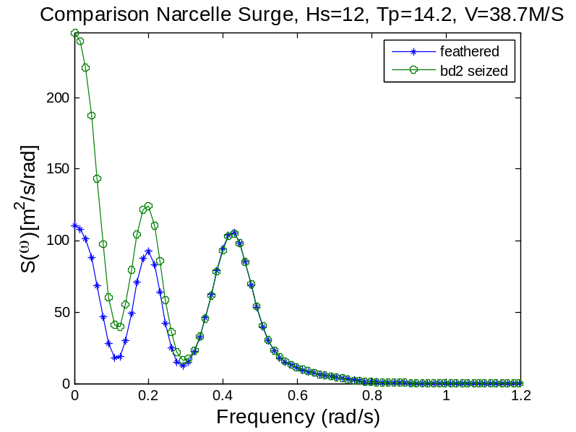
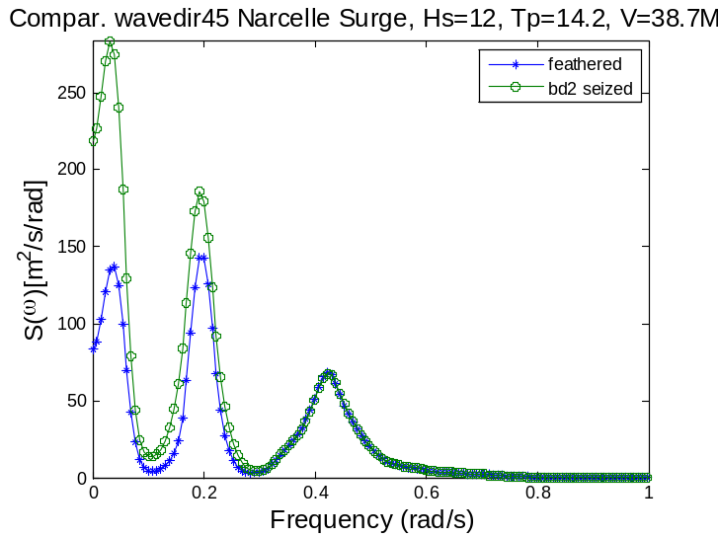
When blade2 is seized, the wave frequency is the same as that of the feathered case, but the pitch resonant response and the surge resonant response is much larger
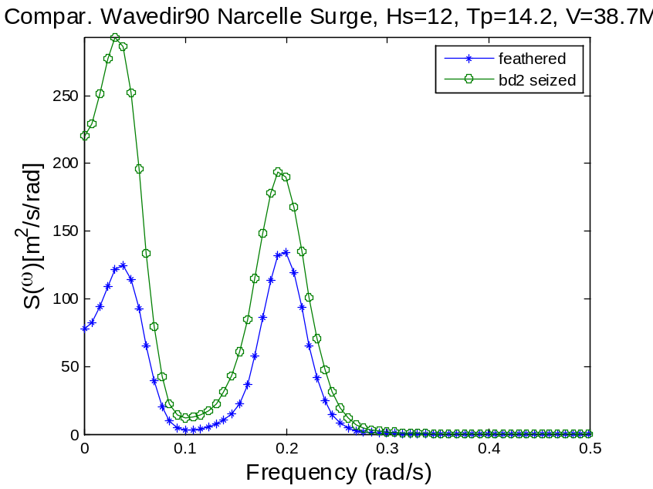
Wp1: surge resonance. Wp2: pitch resonance
When blade2 is flat to the wind while the wave comes from another direction, the aerodynamic damping provided by the blades are not enough to
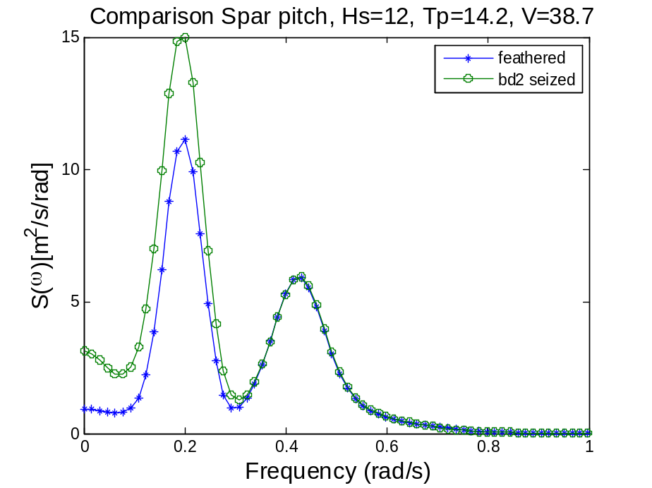
The pitch resonance response for the seized case is more pronounced. The wave freq. response is not affected.
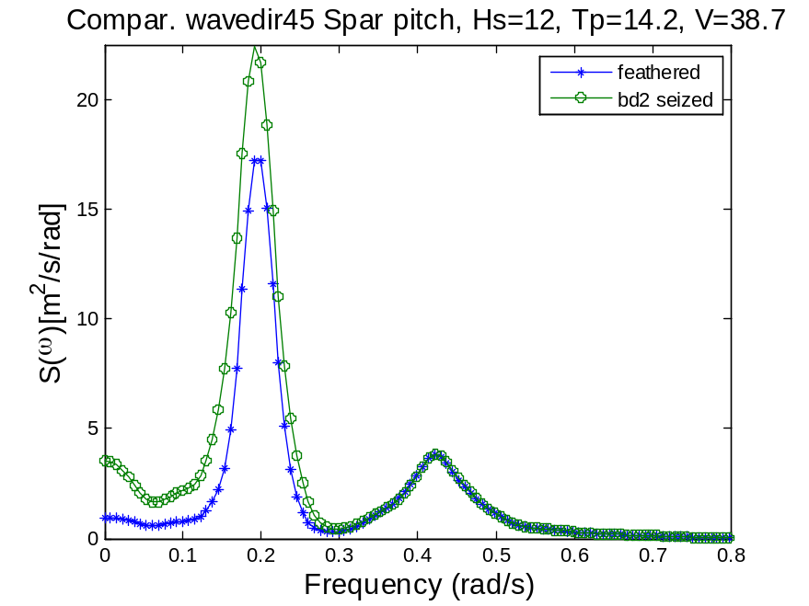
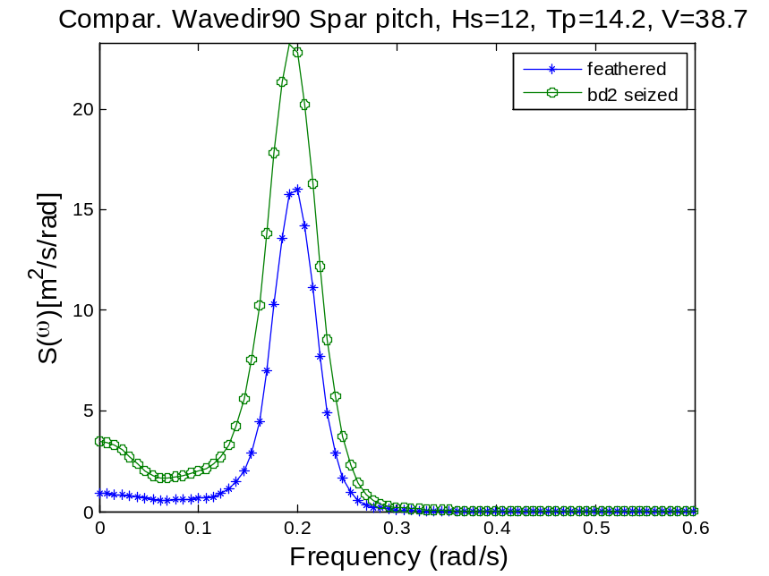
The reason for larger resonance pitch response for blade2seized case is that more aerodynamic force are concentrated on blade2.

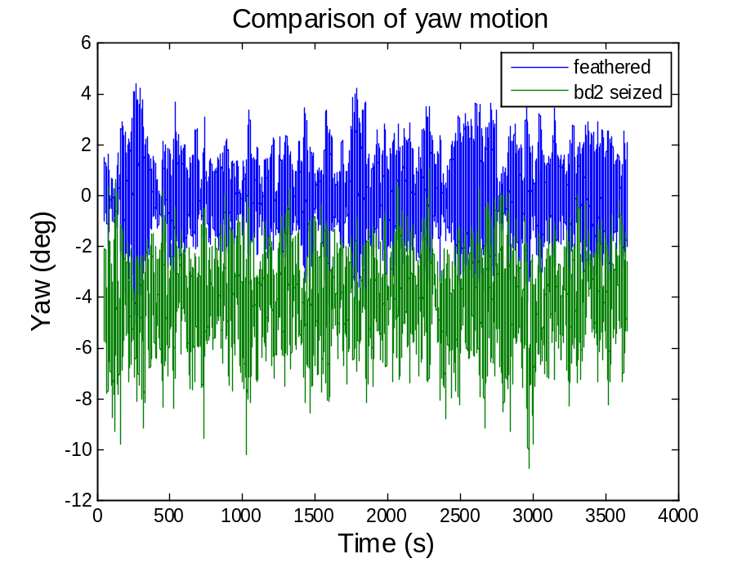
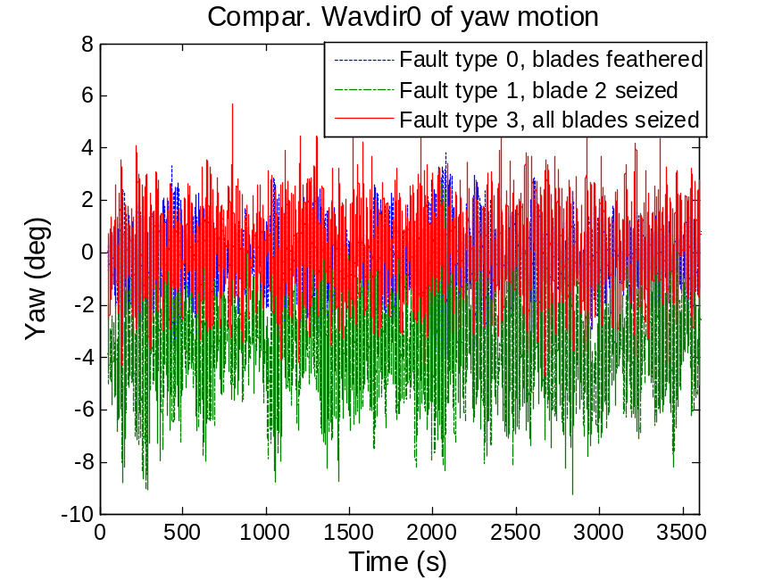
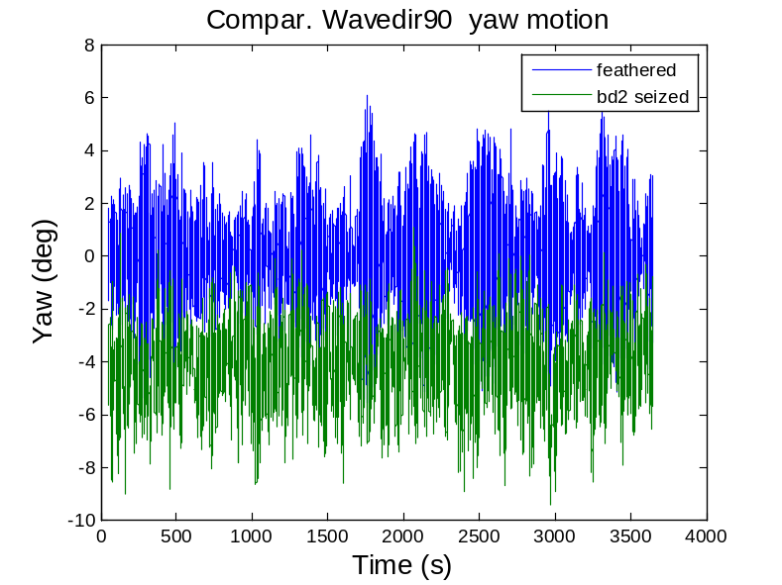

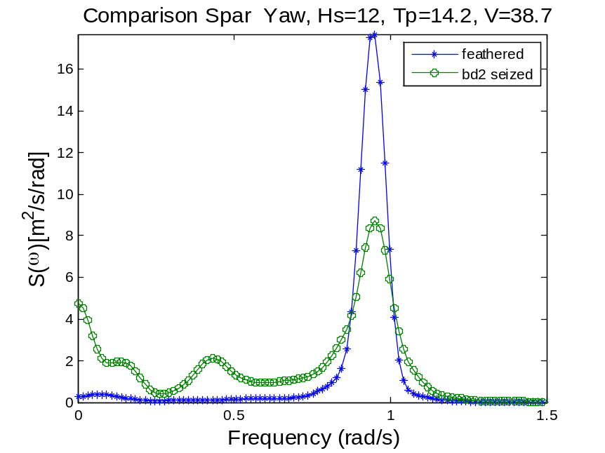
When 1 blade is seized, more resonant response besides the yaw resonance is excited.
Both the roll and wave freq. resonance are present in the seized case. When one blade is flat to the wind, more resonant responses are excited.
But the amplitude of the spectrum of the yaw resonance is damped.
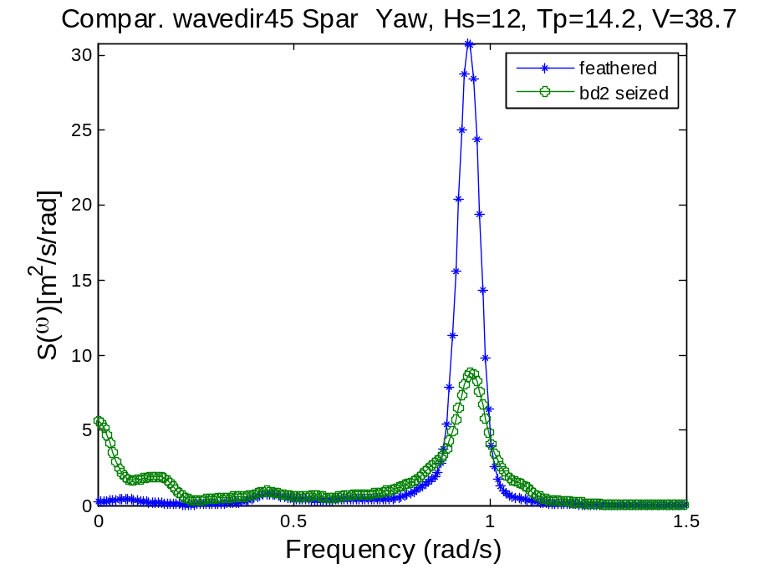
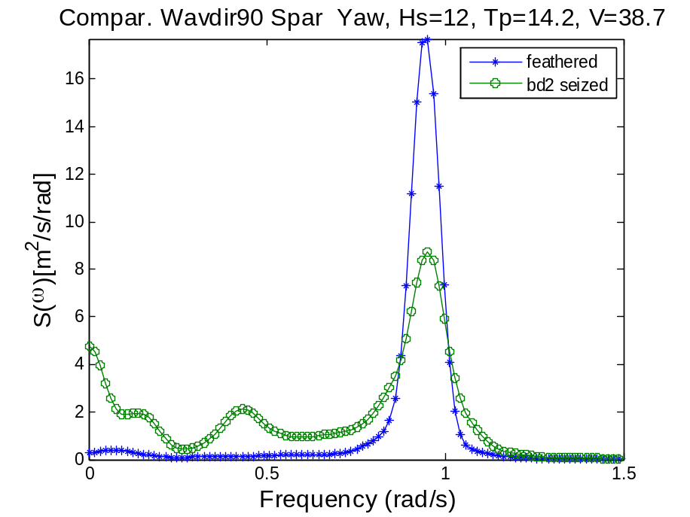
It seems that the wave direction has virtually no impact on the response of the spar. But the seized blade has a direct influence: wave frequency resonance pops up, and there is a slight peak for roll motion.
Postion1:
Wave dir0
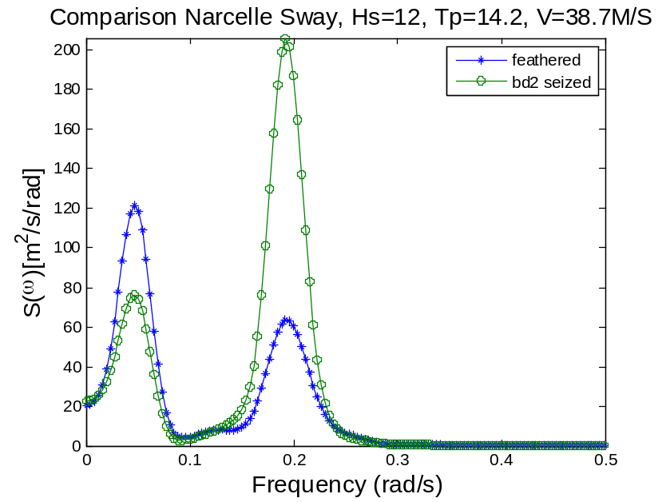
The roll resonant response is much larger for the seized case，but the sway resonance peak is lower.
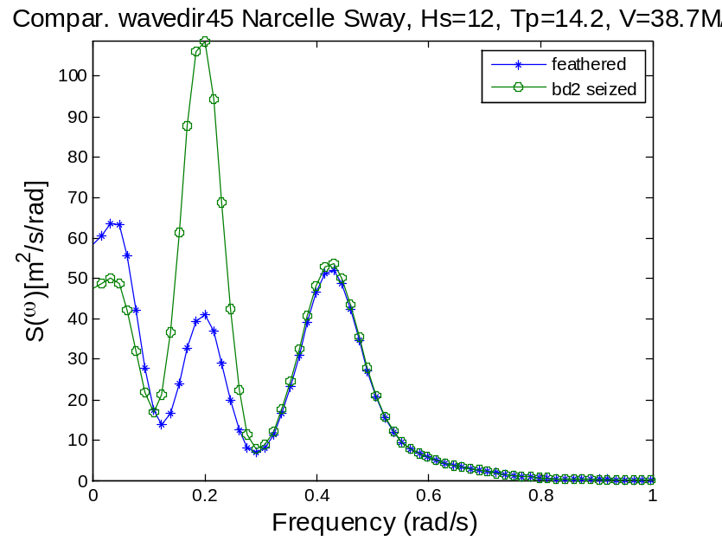
Wave dir90

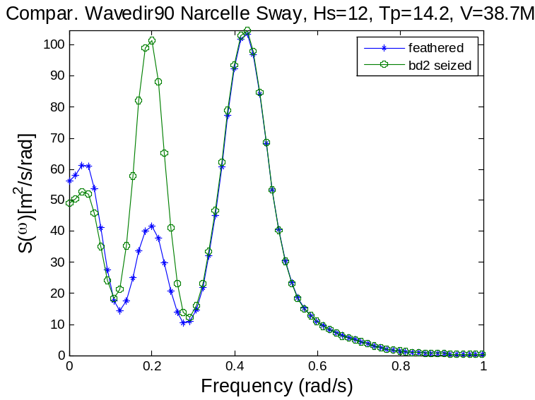
Wp1=0.05 sway, wp2=0.2 roll, wp3=0.43 wave
Position 3:
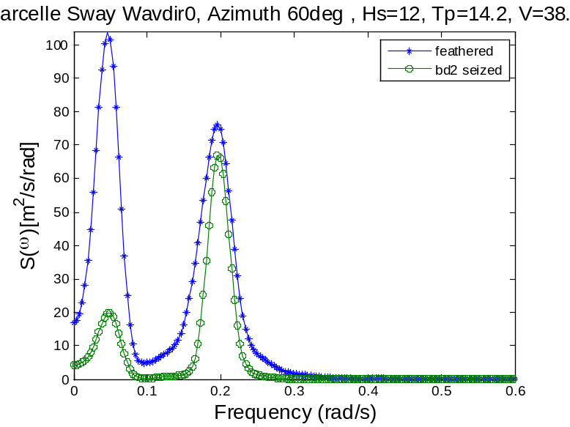

The roll motion and sway motion are coupled for a spar-type wind turbine with lateral symmetry.[1] In the feathered and parked case, all of the blades are flat to the wave direction and parallel to the wind direction, providing enough aerodynamic damping to counteract the roll resonant effect in the sway motion. Compared with the feathered case, the seized case leads to large unwanted roll resonance.

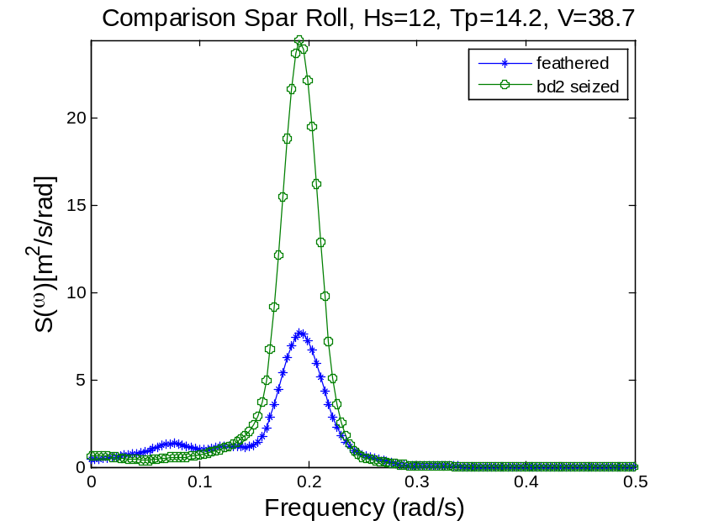
When one blade is seized,

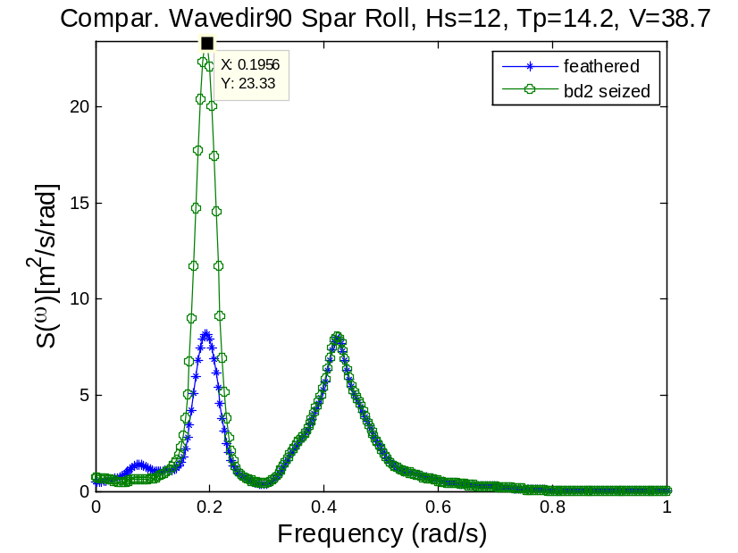
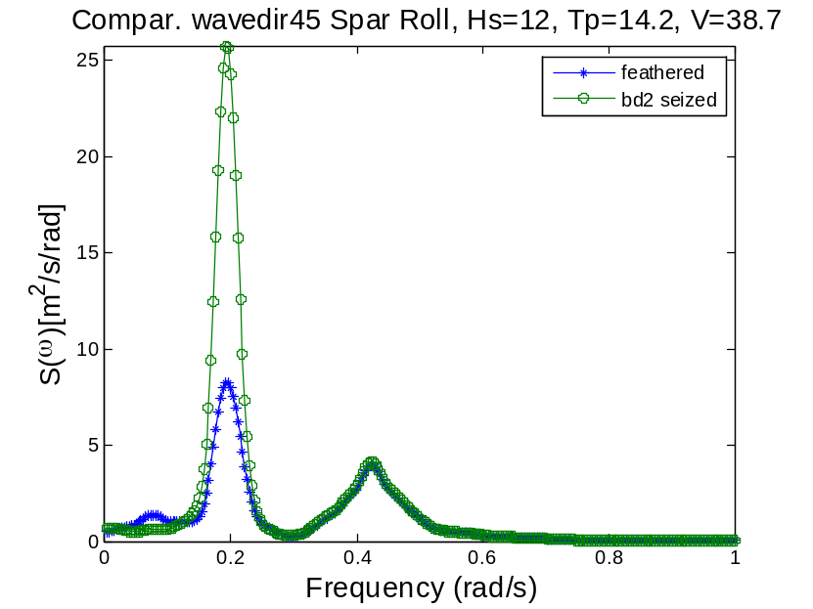
When blade2 is seized, it results in more roll resonance due to the aerodynamic excitation on blade2.

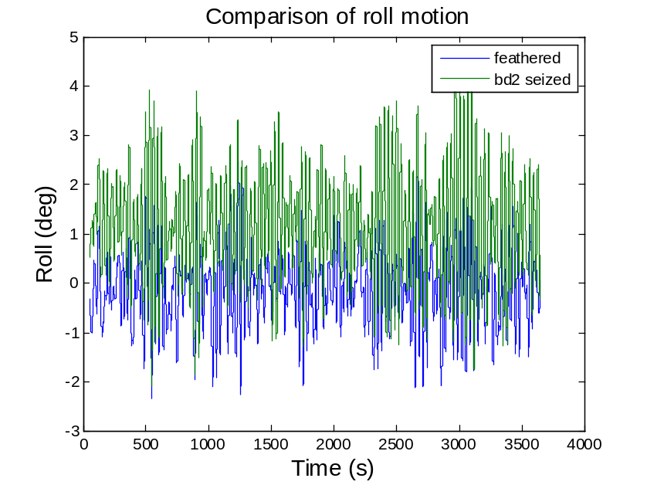
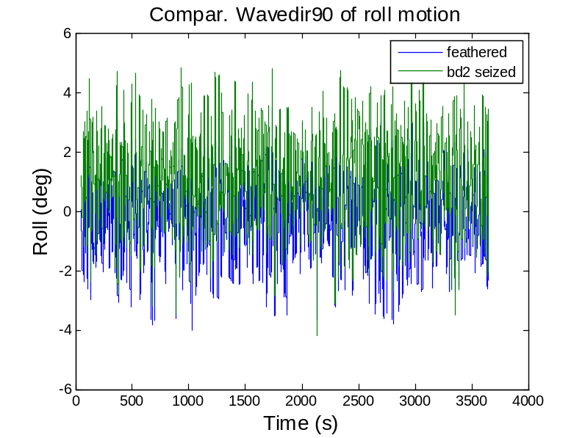

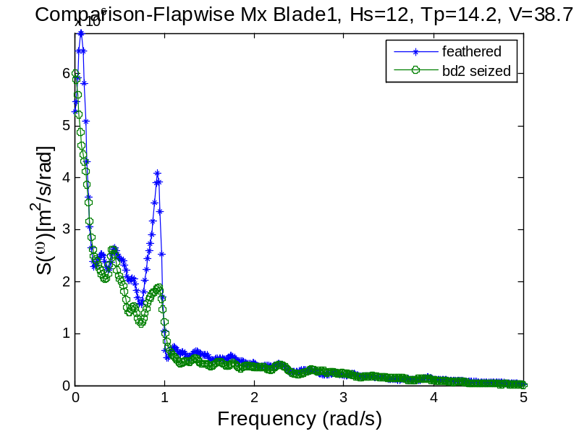
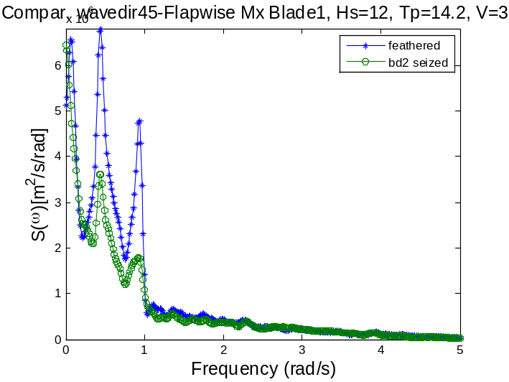
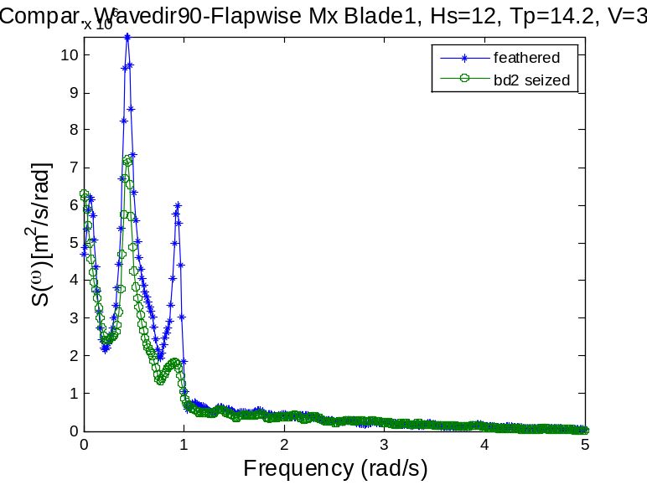
When blade2 is seized and flat to the wind direction, the impact on flapwise motion of blade1 seems to be positive.

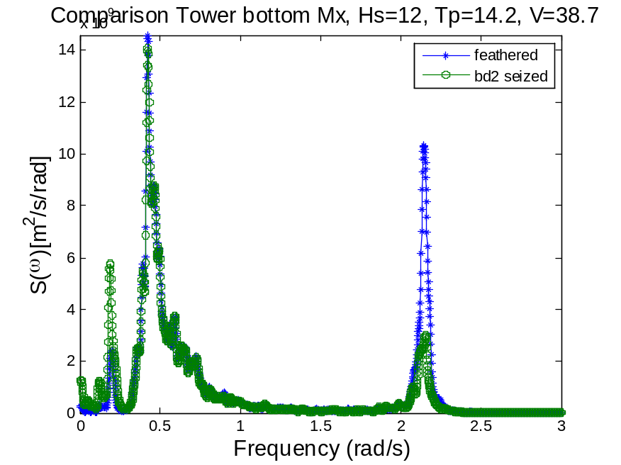

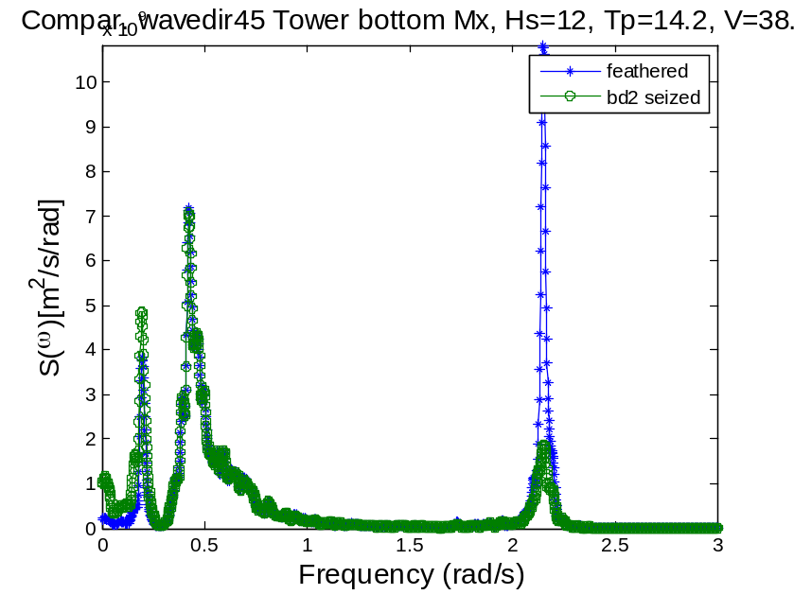
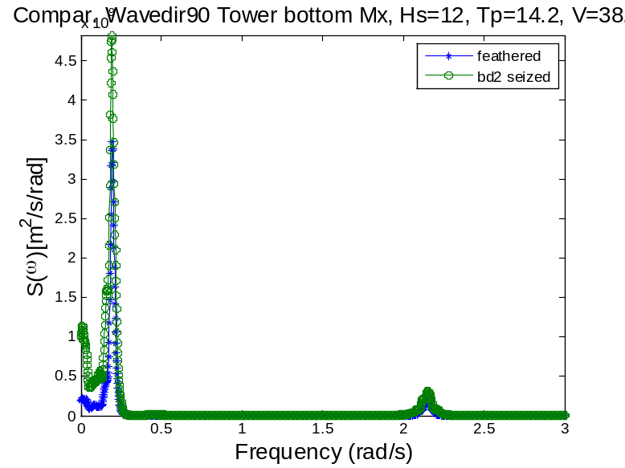
The seized blade added more aerodynamic damping to the motion in fore-aft of the spar, which leads to decreased resonant of the Mx. This benefit is sensitive to the wave direction.
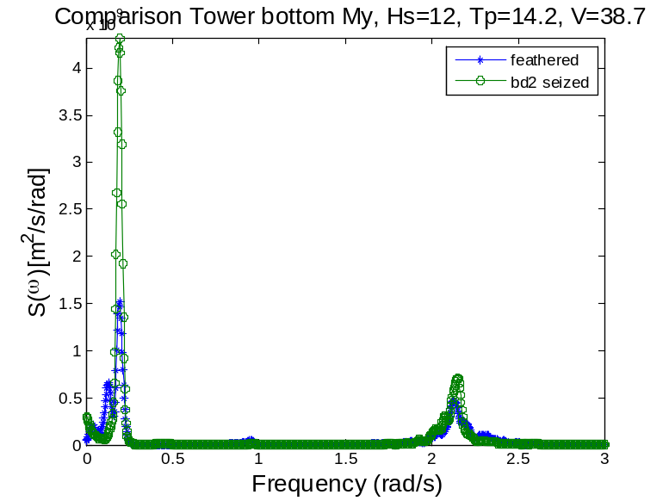
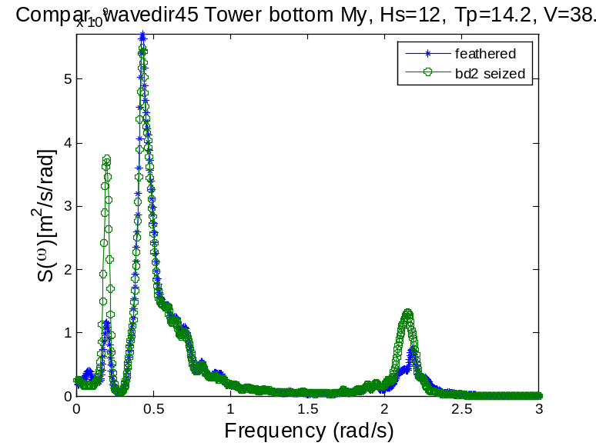

I

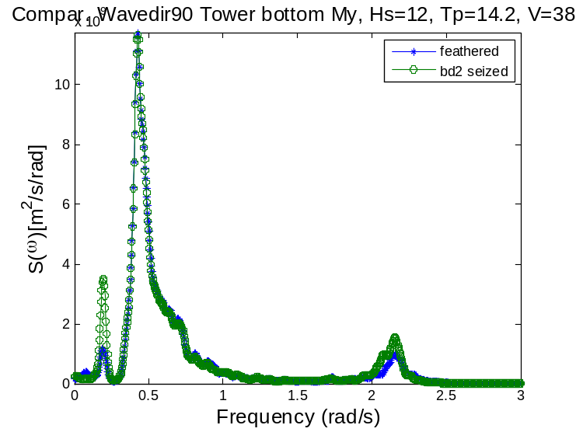
Wp2-2.15rad/s=0.34Hz
n a similar way, the wp1 of My is most affected by the roll resonant response. When only two blades are flat in –y direction, the corresponding damping decreased, leading to a higher response for case2. The seized blade, hence the reduced aerodynamic damping in –x direction will always leads to larger roll resonance in the tower root bending moment My.
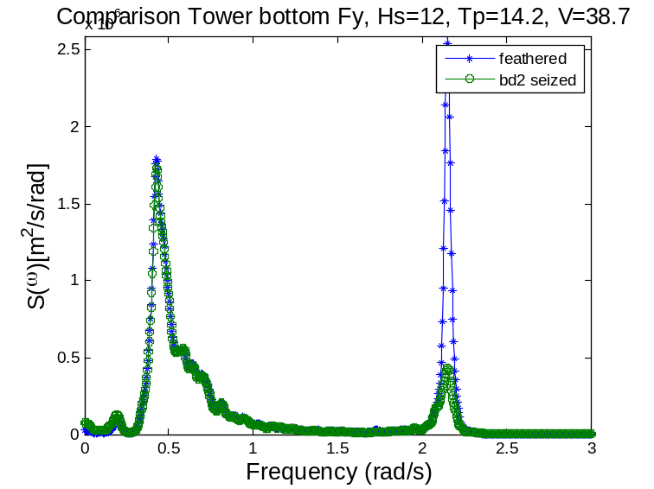
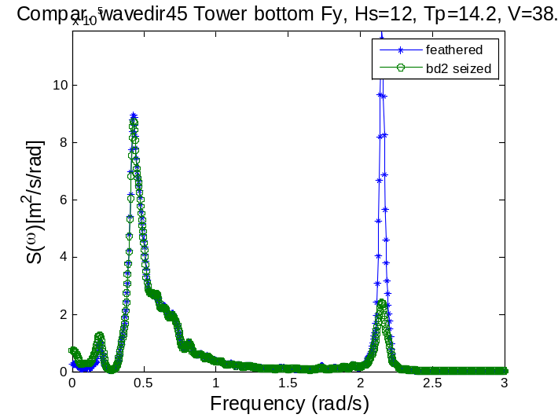

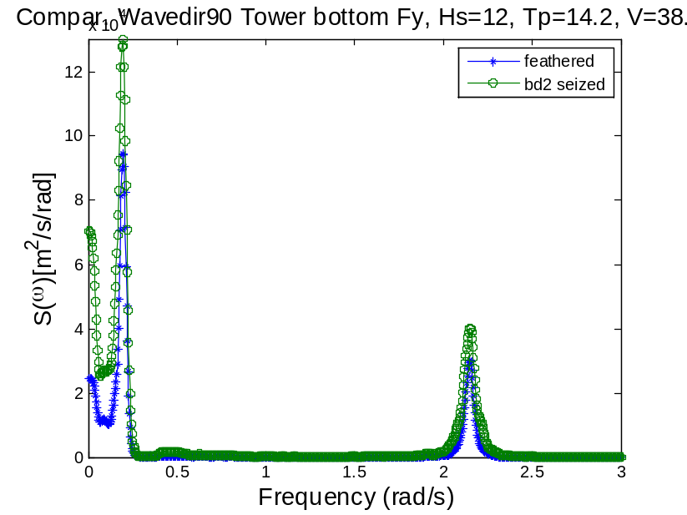
Wp1=0.19 rad/s, pitch resonance wp2=2.15 rad/s, 0.34 Hz, first tower fore-aft
Wave direction has a significant influence on the response. When wave direction=0, the Fy has a prominent peak at wp2 for the feathered case. While wave direction=0, Fy is peaked at the pitch resonance.
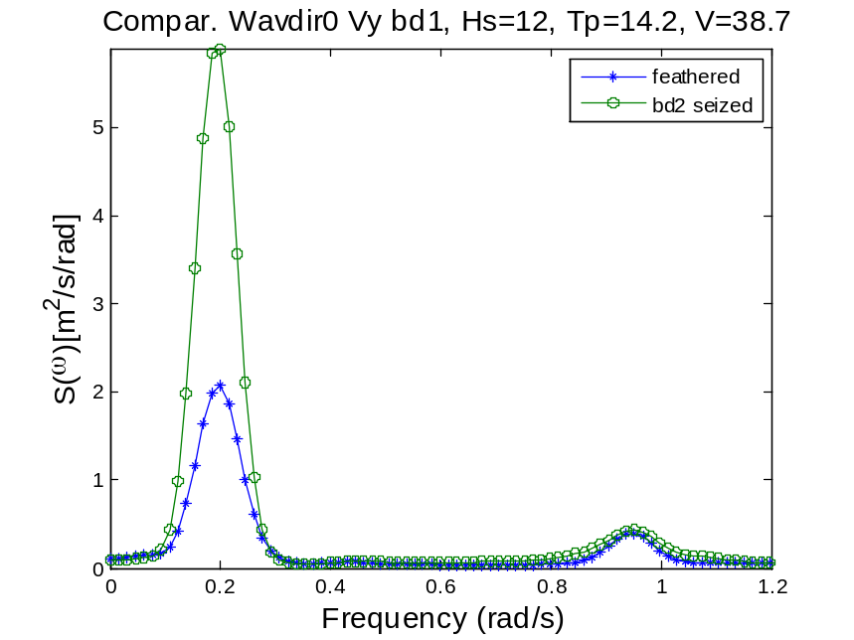
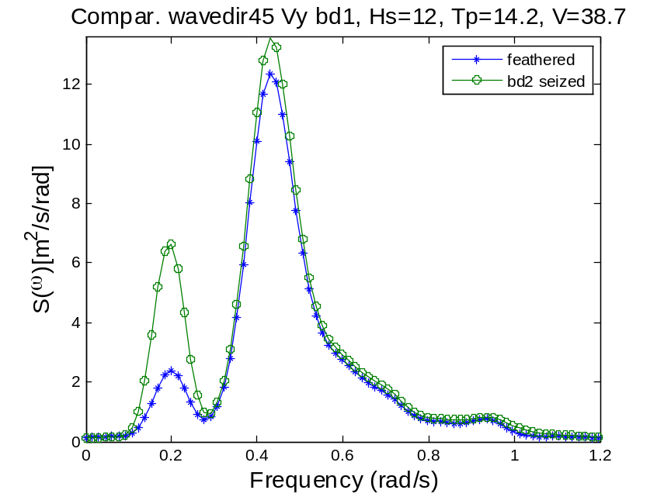
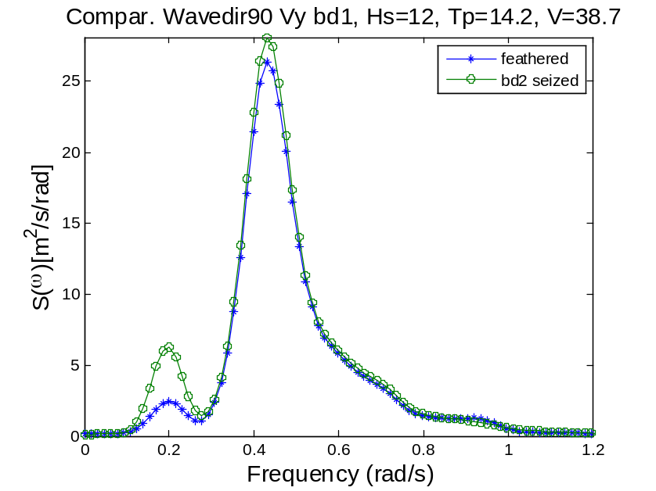
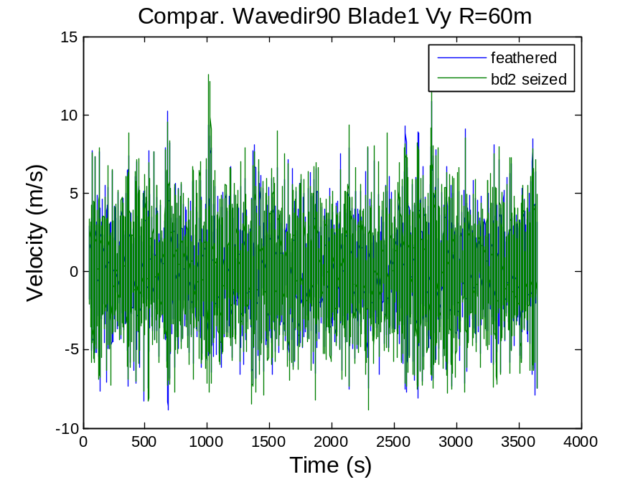
The seized blade leads to larger pitch resonance of the tip speed velocity of blade1 due to the pitch rigid body motion of the platform. The degree of this influence depends very much on the wave direction. Wave direction0 causes more severe pitch resonance compared with wave direction 90.
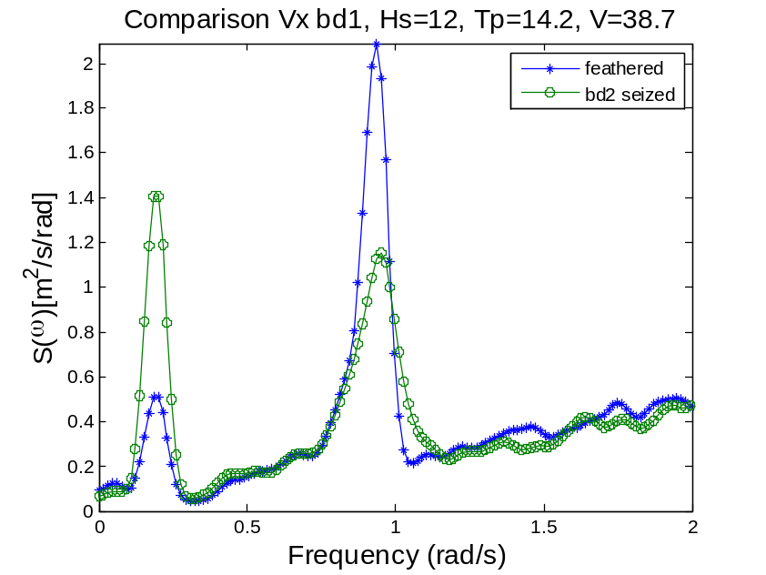
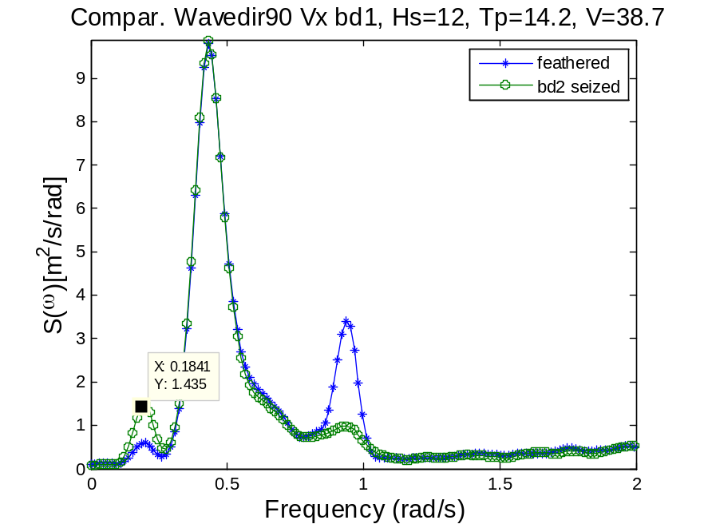
Similar to pitch and yaw behavior.

II. Extreme value and normalized peak responses
The extreme values can be estimated as µ_{x}+kσ_{x}

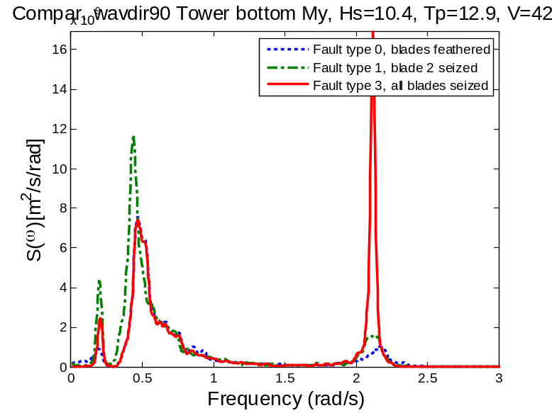
Tower bottom bending moment My spectrum, blade azimuth γ1=30 deg, wave misalignment γ2=90 deg, Sea State B,
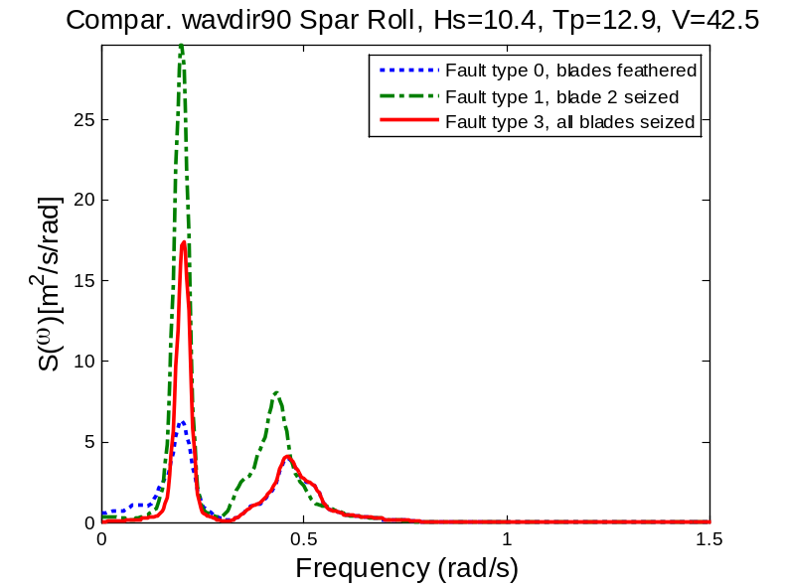
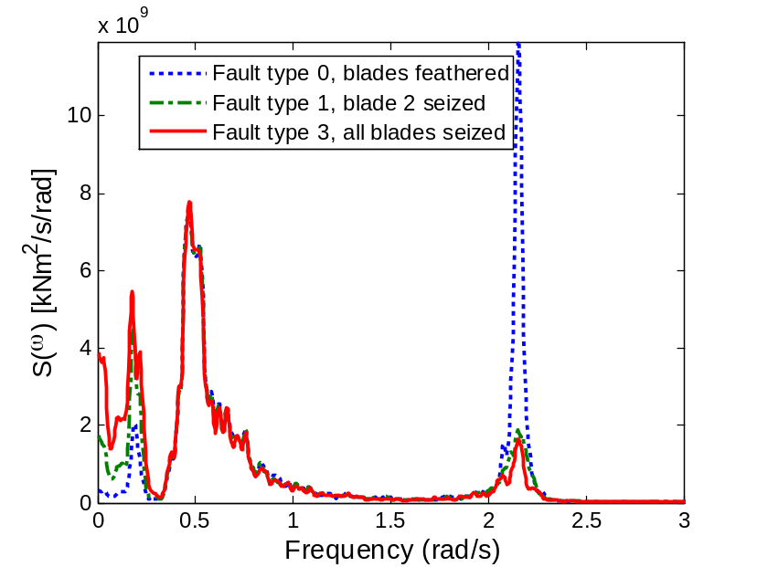
Tower bottom bending moment Mx spectrum, blade azimuth γ1=30 deg, wave misalignment γ2=0 deg, Sea State B
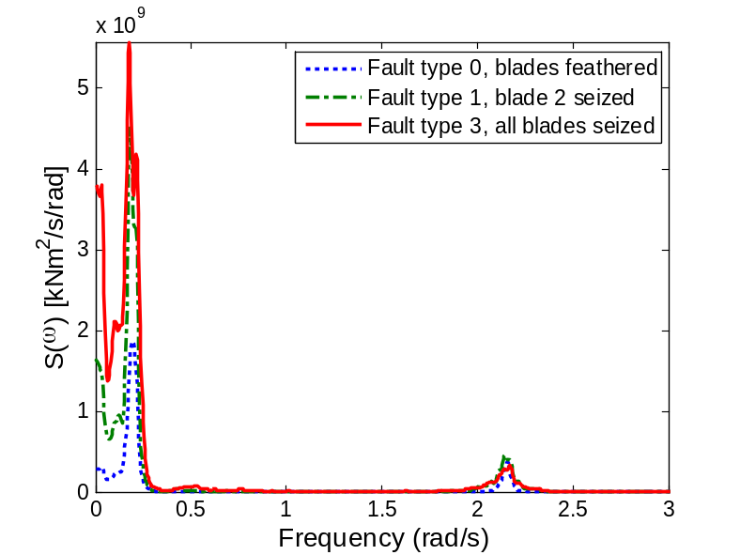
Tower bottom bending moment Mx spectrum, blade azimuth γ1=90 deg, wave misalignment γ2=90 deg, Sea State B
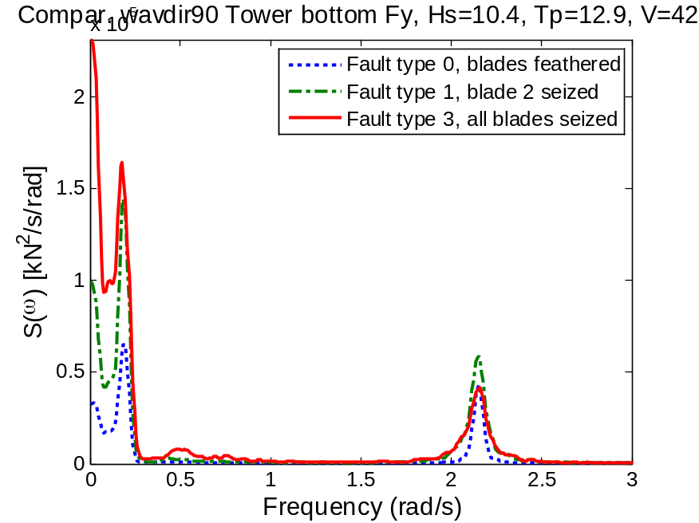

Tower bottom shear force Fy spectrum, blade azimuth γ1=90 deg, wave misalignment γ2=90 deg, Sea State B
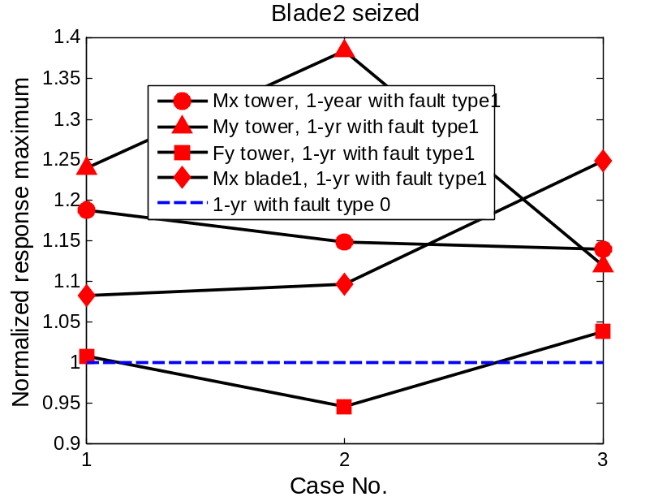

[1] Faltinsen OM. Sea loads on ships and offshore structures: Cambridge Univ Pr; 1993.

